**Retail Spring Boot Application**

The Retail application is developed using Spring Boot. In-memory H2 database is used for storing data. The database and objects are created when starting the application. The test data in given as sql insert statement which will be executed during start-up.

This application is takes checkout request as JSON and applies discounts based on the conditions given below.

1. If the user is an employee of the store, he gets a 30% discount
2. If the user is an affiliate of the store, he gets a 10% discount
3. If the user has been a customer for over 2 years, he gets a 5% discount.
4. For every $100 on the bill, there would be a $ 5 discount (e.g. for $ 990, you get $ 45 as a discount).
5. The percentage-based discounts do not apply on groceries.
6. A user can get only one of the percentage-based discounts on a bill.

The application is designed and developed by considering below points

1. Object oriented programming approach.
2. Test driven development
3. Simple and generic coding best practices conventions

Completed the below points

* Working application which is available in GIT - <https://github.com/jasarmcj/retail.git>
* High level design diagrams including class diagram
* Code coverage of junits test. Coverage report is generated JACOCO which is integrated along with maven build
* API documentations is done by using Swagger

The details of code setup and execution is given in README.md file inside the project.

**High Level Design**

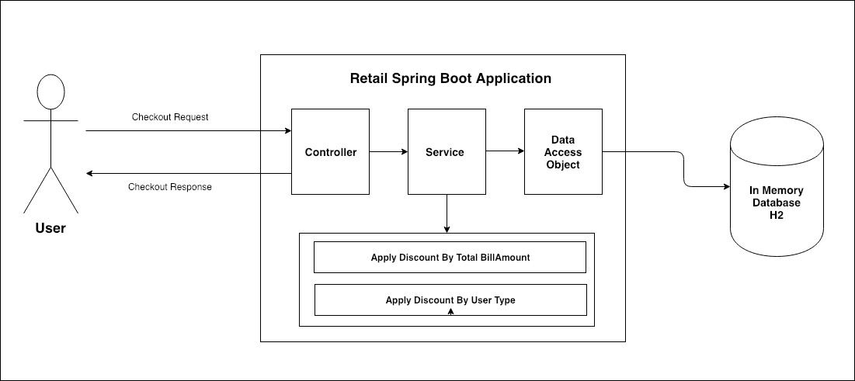

**Class Diagram**

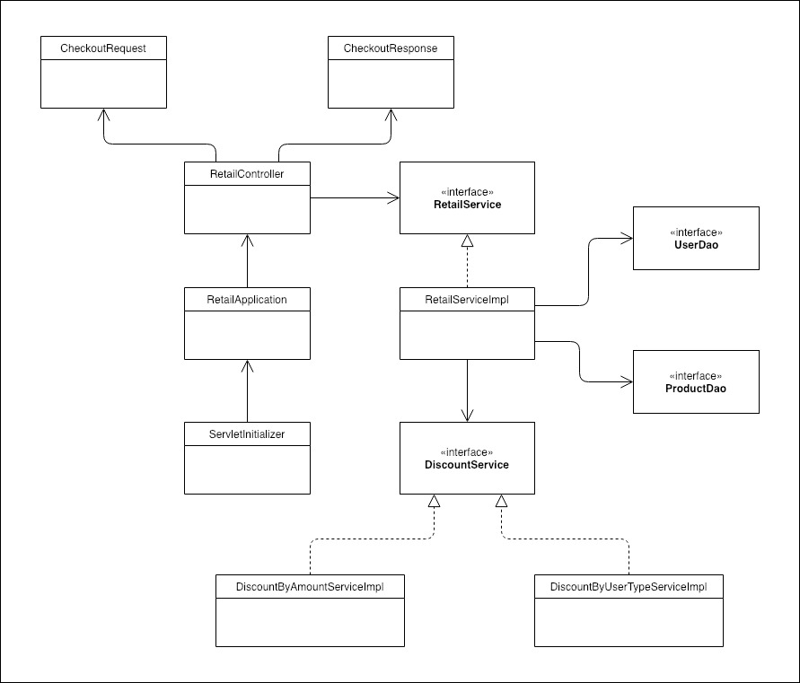

**Code Coverage Report**

Code coverage report is generated using JACOCO. Image below sows coverage report generated using jacoco maven plugin. The code coverage is more than 80%.

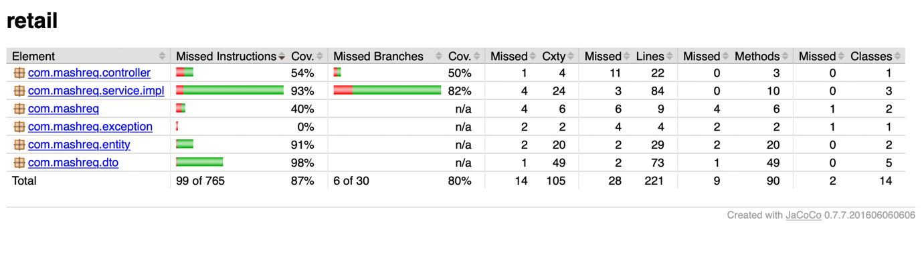

**Swagger API Documentation**

API documentation is done using Swagger. Screen shot of swagger integration is below. Sample request JSON and response JSON is available in swagger.

<http://localhost:8080/swagger-ui.html>

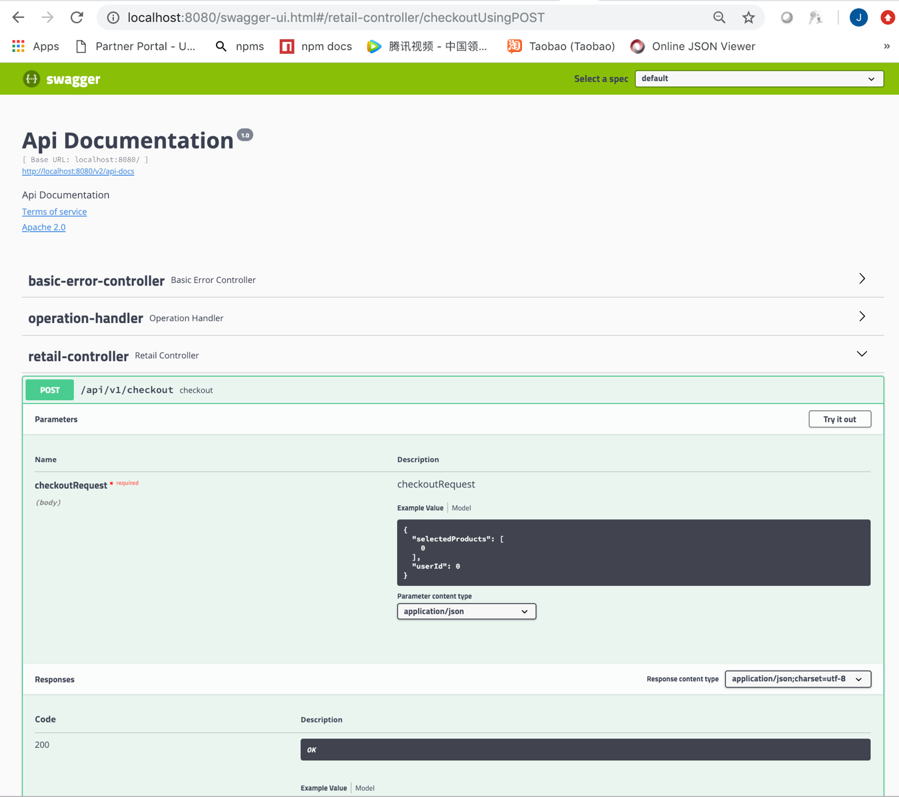

**API Details**

**URL:** http://localhost:8080/api/v1/checkout

**Method:** POST

**Request JSON**

{

"selectedProducts": [

2001, 2002,2004

],

"userId": 1001

}

**Sample Response**

{

"status": "SUCCESS",

"message": "Operation successful",

"data": {

"user": {

"userId": 1001,

"userName": "Jasar",

"userType": "EMPLOYEE",

"discountPercentage": 0,

"userRegisterDate": "2018-05-01"

},

"totalPrice": 23500,

"totalDiscount": 23500,

"totalPriceAfterDiscount": 0,

"selectedProducts": [

{

"productId": 2001,

"productName": "Television",

"productType": "ELECTRONICS",

"productPrice": 20000,

"productPriceAfterDiscount": 20000,

"discountPercentage": 0,

"discountAllowed": false

},

{

"productId": 2002,

"productName": "Shirt",

"productType": "LIFESTYLE",

"productPrice": 3000,

"productPriceAfterDiscount": 3000,

"discountPercentage": 0,

"discountAllowed": false

},

{

"productId": 2004,

"productName": "Wheat",

"productType": "GROCERY",

"productPrice": 500,

"productPriceAfterDiscount": 500,

"discountPercentage": 0,

"discountAllowed": false

}

]

}

}